1. Download the file called network.ova



2. Go to VirtualBox manager or something similar, click on machine and add new

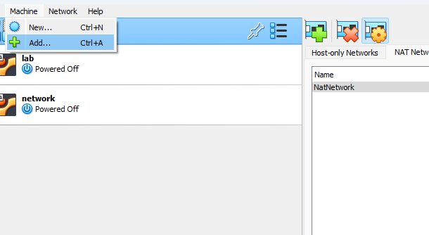

3. Go to Tools – Nat network – click on green plus to create a NAT network.

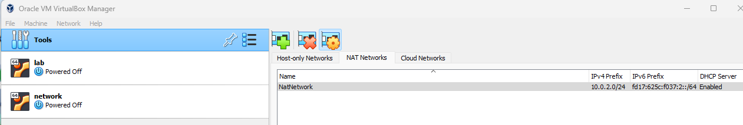

4.Now go the settings and copy the features (not the hardware like base memory for example)

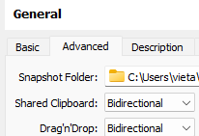

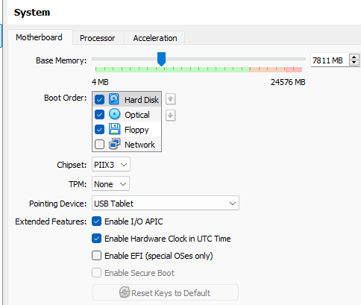

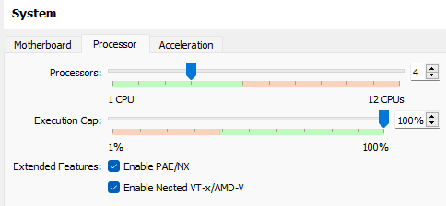

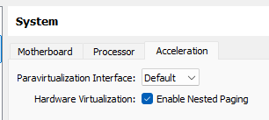

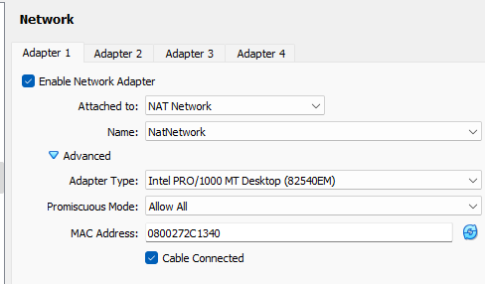

# Common problems

## **1. Make sure virtualization is enabled in BIOS/UEFI**

Check if your CPU supports Intel VT-x / AMD-V and enable it in BIOS.

## **2. Check and disable Hyper-V or conflicting features on Windows**

Disable if active:

* Hyper-V
* Virtual Machine Platform
* Windows Hypervisor Platform

Commands to disable them (in PowerShell as Administrator):

DISM /Online /Disable-Feature:Microsoft-Hyper-V-All  
DISM /Online /Disable-Feature:VirtualMachinePlatform  
DISM /Online /Disable-Feature:WindowsHypervisorPlatform

Then **reboot**.

## **3. Install or fix VirtualBox properly**

Uninstall and reinstall the latest stable VirtualBox from the official site.

## **4. Set PATH to VBoxManage manually (optional)**

## Either:

Run VBoxManage by typing full path, like:

& "C:\Program Files\Oracle\VirtualBox\VBoxManage.exe" --version

or

Add C:\Program Files\Oracle\VirtualBox\ to your system PATH (so you can type VBoxManage anywhere).

## **5. Enable nested virtualization manually via VBoxManage**

Use this command:

& "C:\Program Files\Oracle\VirtualBox\VBoxManage.exe" modifyvm "VM_Name" --nested-hw-virt on

(Replace "VM_Name" with your VM’s real name, like "d".)

## **6. Verify if it worked**

Check:

& "C:\Program Files\Oracle\VirtualBox\VBoxManage.exe" showvminfo "VM_Name"

Look for this line:

Nested VT-x/AMD-V: enabled

If you see it means that it worked.